# YELLOW BOX TESTING

Testing the warning message of an application is called as yellow box testing.

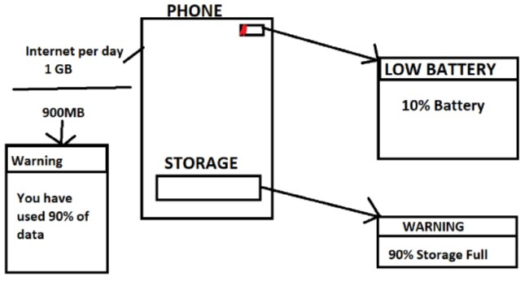

# COMPARISON TESTING

Testing the newly build application with the similar kind of application which is released in the market, here we compare the application, check the advantages and dis-advantages and check whether all the features are present in our newly built application or not.



Non-Functional Testing

# ACCESSIBILITY TESTING

Testing the user friendliness of an application from physically challenged people point of view.



# RELIABILITY TESTING

Testing the functionality of an application continuously for a particular period of time is called as reliability testing.

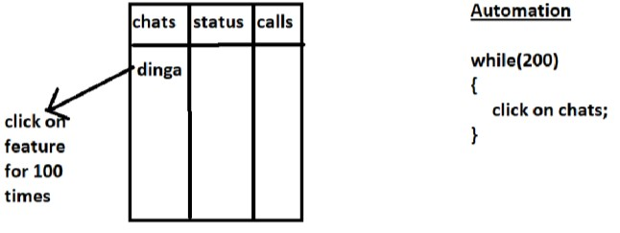

# RECOVERY TESTING

Testing the functionality of an application to check well the application recovers the data from the crash or disasters.

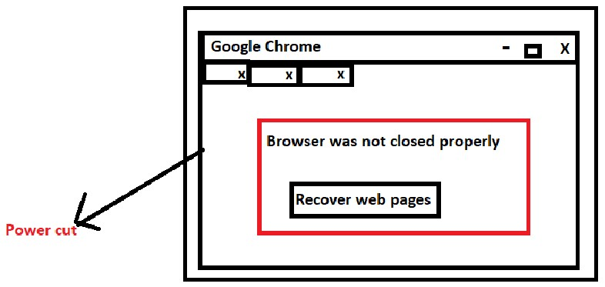

# Compliance testing :

It is a type of non-functional testing which is done to check the sw that that is developed meets the company standard organization respective standards or not.

# Pilot testing :

It is done by set of people wherein they do trail run on project give feedback about project to company before release

# Risk based testing :

It is testing done by test engineer for the project based on the risk. Here test engineer will test feature or functionality

# Migration testing :

Whenever the technology is outdated or when database is outdated that time we will migrate from old technology to new technology or from old database to latest database, in that case we go for migration testing.

# Interrupt testing :

It is a process of replicating the interrupt or process of replicating abrupt interrupt in application or software is called as interrupt testing. What are the types of requirement .

# System integration testing :

Testing the dataflow between 2 different system or software or application and also make sure that end to end business flow is working fine between 2 system or application as expected Is called as System integration testing. Ex : whatsapp >> invite friends >>> fb messenger……